**Explication des données ecowatt :**

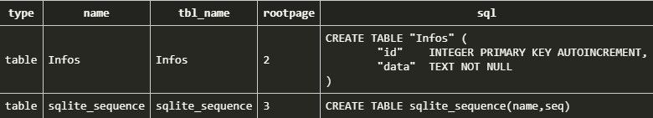

Chaque ligne de la table Infos ont cette forme. Voici la première ligne avec des tabulations pour mieux comprendre l’architecture de la table Infos.

{

"signals": [

{

"GenerationFichier": "2022-06-03T07:36:25+02:00",

"jour": "2022-06-06T00:00:00+02:00",

"dvalue": 1,

"message": "Situation normale ",

"values": [

{

"pas": 0,

"hvalue": 1

},

{

"pas": 1,

"hvalue": 1

},

{

"pas": 2,

"hvalue": 1

},

{

"pas": 3,

"hvalue": 1

},

{

"pas": 4,

"hvalue": 1

},

{

"pas": 5,

"hvalue": 1

},

{

"pas": 6,

"hvalue": 1

},

{

"pas": 7,

"hvalue": 1

},

{

"pas": 8,

"hvalue": 1

},

{

"pas": 9,

"hvalue": 1

},

{

"pas": 10,

"hvalue": 1

},

{

"pas": 11,

"hvalue": 1

},

{

"pas": 12,

"hvalue": 1

},

{

"pas": 13,

"hvalue": 1

},

{

"pas": 14,

"hvalue": 1

},

{

"pas": 15,

"hvalue": 1

},

{

"pas": 16,

"hvalue": 1

},

{

"pas": 17,

"hvalue": 1

},

{

"pas": 18,

"hvalue": 1

},

{

"pas": 19,

"hvalue": 1

},

{

"pas": 20,

"hvalue": 1

},

{

"pas": 21,

"hvalue": 1

},

{

"pas": 22,

"hvalue": 1

},

{

"pas": 23,

"hvalue": 1

}

]

},

{

"GenerationFichier": "2022-06-03T07:36:25+02:00",

"jour": "2022-06-04T00:00:00+02:00",

"dvalue": 3,

"message": "Coupures d'électricité programmées",

"values": [

{

"pas": 0,

"hvalue": 1

},

{

"pas": 1,

"hvalue": 1

},

{

"pas": 2,

"hvalue": 1

},

{

"pas": 3,

"hvalue": 1

},

{

"pas": 4,

"hvalue": 1

},

{

"pas": 5,

"hvalue": 2

},

{

"pas": 6,

"hvalue": 2

},

{

"pas": 7,

"hvalue": 3

},

{

"pas": 8,

"hvalue": 3

},

{

"pas": 9,

"hvalue": 3

},

{

"pas": 10,

"hvalue": 3

},

{

"pas": 11,

"hvalue": 3

},

{

"pas": 12,

"hvalue": 3

},

{

"pas": 13,

"hvalue": 2

},

{

"pas": 14,

"hvalue": 2

},

{

"pas": 15,

"hvalue": 2

},

{

"pas": 16,

"hvalue": 2

},

{

"pas": 17,

"hvalue": 3

},

{

"pas": 18,

"hvalue": 3

},

{

"pas": 19,

"hvalue": 3

},

{

"pas": 20,

"hvalue": 2

},

{

"pas": 21,

"hvalue": 2

},

{

"pas": 22,

"hvalue": 2

},

{

"pas": 23,

"hvalue": 2

}

]

},

{

"GenerationFichier": "2022-06-03T07:36:25+02:00",

"jour": "2022-06-05T00:00:00+02:00",

"dvalue": 2,

"message": "Risque de coupures d'électricité",

"values": [

{

"pas": 0,

"hvalue": 1

},

{

"pas": 1,

"hvalue": 1

},

{

"pas": 2,

"hvalue": 1

},

{

"pas": 3,

"hvalue": 1

},

{

"pas": 4,

"hvalue": 1

},

{

"pas": 5,

"hvalue": 1

},

{

"pas": 6,

"hvalue": 1

},

{

"pas": 7,

"hvalue": 2

},

{

"pas": 8,

"hvalue": 2

},

{

"pas": 9,

"hvalue": 2

},

{

"pas": 10,

"hvalue": 2

},

{

"pas": 11,

"hvalue": 2

},

{

"pas": 12,

"hvalue": 1

},

{

"pas": 13,

"hvalue": 1

},

{

"pas": 14,

"hvalue": 1

},

{

"pas": 15,

"hvalue": 1

},

{

"pas": 16,

"hvalue": 1

},

{

"pas": 17,

"hvalue": 2

},

{

"pas": 18,

"hvalue": 2

},

{

"pas": 19,

"hvalue": 1

},

{

"pas": 20,

"hvalue": 1

},

{

"pas": 21,

"hvalue": 1

},

{

"pas": 22,

"hvalue": 1

},

{

"pas": 23,

"hvalue": 1

}

]

},

{

"GenerationFichier": "2022-06-03T07:36:25+02:00",

"jour": "2022-06-03T00:00:00+02:00",

"dvalue": 3,

"message": "Coupures d'électricité en cours",

"values": [

{

"pas": 7,

"hvalue": 3

},

{

"pas": 8,

"hvalue": 3

},

{

"pas": 9,

"hvalue": 1

},

{

"pas": 10,

"hvalue": 1

},

{

"pas": 11,

"hvalue": 1

},

{

"pas": 12,

"hvalue": 1

},

{

"pas": 13,

"hvalue": 1

},

{

"pas": 14,

"hvalue": 3

},

{

"pas": 15,

"hvalue": 3

},

{

"pas": 16,

"hvalue": 3

},

{

"pas": 17,

"hvalue": 3

},

{

"pas": 18,

"hvalue": 3

},

{

"pas": 19,

"hvalue": 3

},

{

"pas": 20,

"hvalue": 3

},

{

"pas": 21,

"hvalue": 2

},

{

"pas": 22,

"hvalue": 2

},

{

"pas": 23,

"hvalue": 2

}

]

}

]

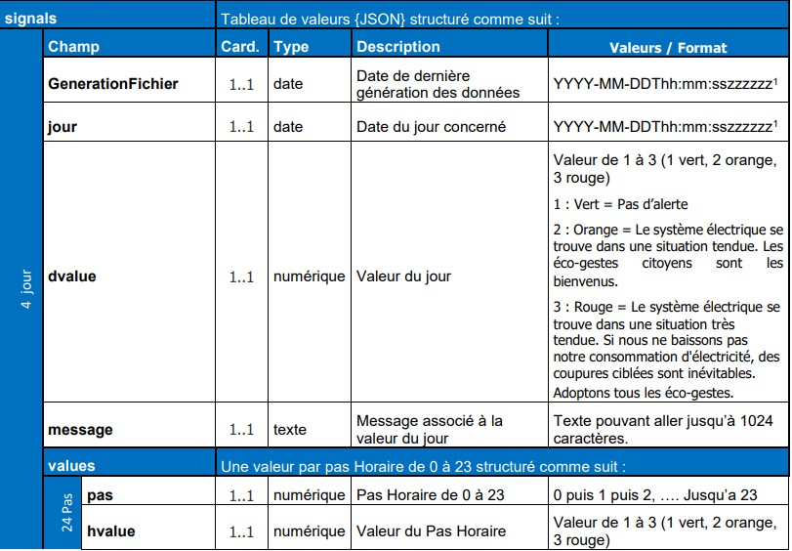}

Une ligne générer le 15 décembre à 23h auras comme données les jours : 16, 17, 18 et 19 décembre.

**Squelette :**

Page d’accueil :

Le but est d’afficher un graphique, tableau ou quelconque afficheur pour savoir si oui ou non il y a un risque de coupure d’électricité avenir sur J+4 (4 jours futurs ou 3 à nous e choisir).

Page de conseil :

Plusieurs astuces permettant de moins consommer d’électricité et de limité les coupures de courants.

**PDF :**

Double clique dessus pour l’ouvrir.

